

Configuring a Palo Alto
Small Office/Home Office
Environment

Rui Zhao, CCNA

Purpose:

The purpose of configuring a SOHO (Small Office/Home Office) environment is to provide users and customers with secure and reliable network connectivity for a small-scale organization. A SOHO environment can ensure protection from cyber threats, managing traffic, and ensure safe access to resources.

Background Information:

A SOHO (Small Office/Home Office) network is designed for accessing the internet via computer and to communicate in an area that is relatively small. This can include small businesses, freelancers, or remote workers who are operating from home or in a compact office environment.

The SOHO network combines home networking convenience with security. Within a typical SOHO network, it connects with a limited number of devices such as computers, printers, security cameras, and smart devices through a central router or firewall like the PA-220. This grants access to the internet and internal resources.

The goal of a SOHO network is to ensure connectivity, performance, and security. Users may often require stable connection to cloud services, file sharing, video conferencing, and remote access to corporate networks. All these services can be hosted via the SOHO environment if adjusted correctly.

Furthermore, SOHO emphasizes simplicity, cost-effectiveness, and easy management. However, as difficult cyberattacks are starting to target smaller businesses like SOHO, robust security measures like firewalls and VPNs have become an essential component of SOHO designs.

Within working aspects, there has been a rise of remote work and hybrid offices, driving the demand for reliable SOHO infrastructures. Thus, knowing how to configure a SOHO environment has evolved to become ever so important. Employees working from home may often handle sensitive data or connect to corporate systems, so a properly configured SOHO environment is important for data protection, secure access to assets, and business continuity.

One of the most employed components of SOHO designs is firewalls. A firewall is a network security device that monitors, filters, and controls incoming and outgoing traffic based on predetermined security rules.

Firewalls essentially act as a barrier between trusted internal networks and untrusted external networks (like the internet). They can prevent malicious activity, improve security via security policies, safeguard user data, and prevent unauthorized access.

The PA-220 firewall, for example, is a Next-Generation Firewall (NGFW) specifically designed for small office locations (SOHO). The PA-220 firewall is especially recommended in offices that require enterprise-grade security in a compact form factor. Despite its size, the PA-220 functions just like larger Palo Alto firewalls with the same advanced capabilities, making it ideal for SOHO environments that seek both simplicity and security.

Within the SOHO environment, it serves many practical uses in both business and personal productivity settings. It also offers backup and cloud syncing, allowing seamless connection to cloud storage or backup services. In the process of doing so, it ensures data encryption and integrity.

With all these factors that combine performance and security, SOHO setups help small businesses maintain professional reliability without enterprise-level cost, making SOHO setups extremely cost-effective and efficient. Administrators of the network can additionally prioritize business applications, monitor bandwidth usage, establish VPN tunnels, and establish URL filtering for security purposes.

Lab Summary:

Using the Palo Alto Firewall PA-220, we were able to connect and manage the firewall through the management interface (WebGUI). Then, we constructed security zones, connected to wireless routers, configured layer 2 ports, VLAN interfaces, DHCP, security profile, and outbound internet security & NAT policy, ultimately setting up a reliable SOHO environment.

Configurations:

Before Configuration/Committing
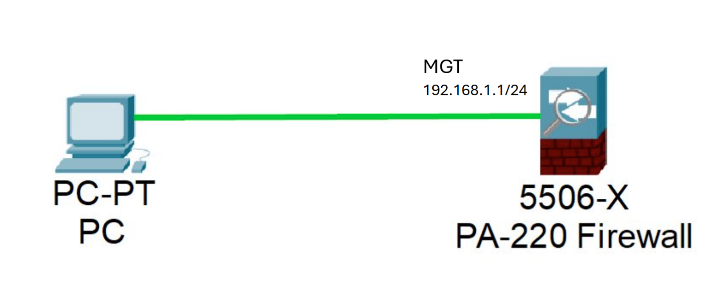

After Configuration/Committing
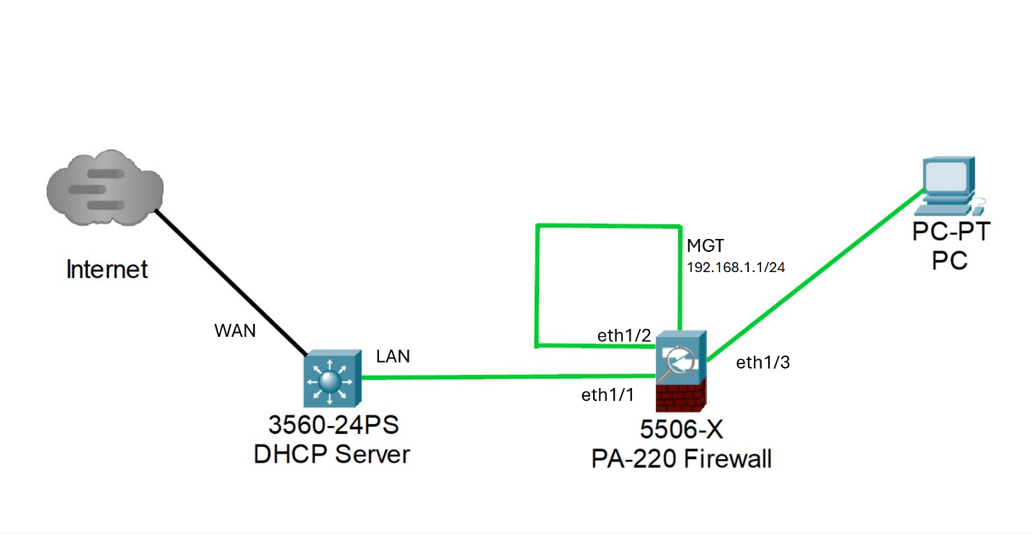

Lab Commands:

Head over to the start menu and search for Control Panel
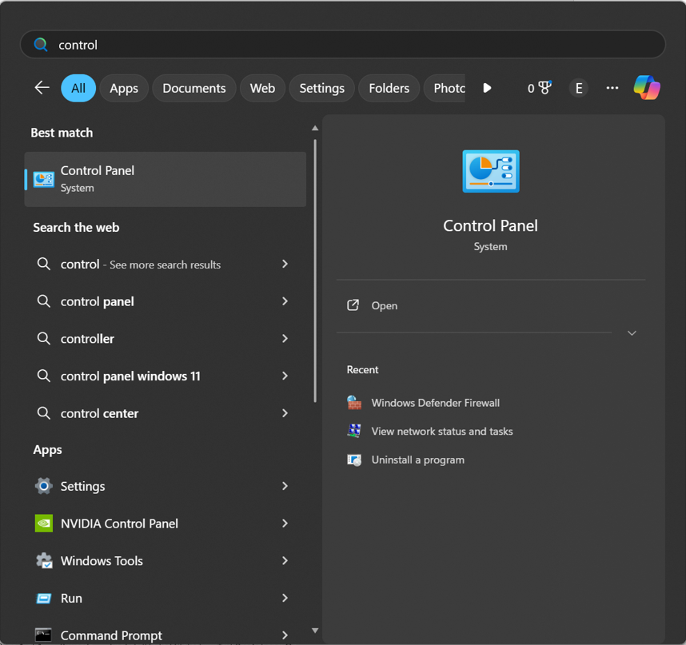

Find Network and Internet and press View network status and tasks. Then, found on the side, click on Change adapter settings.

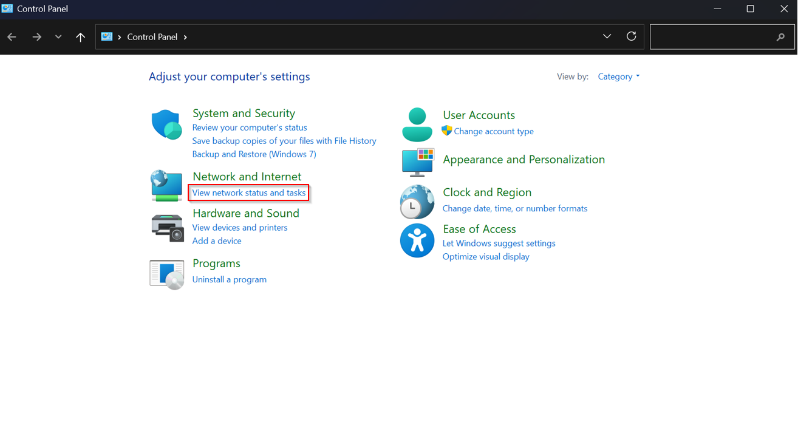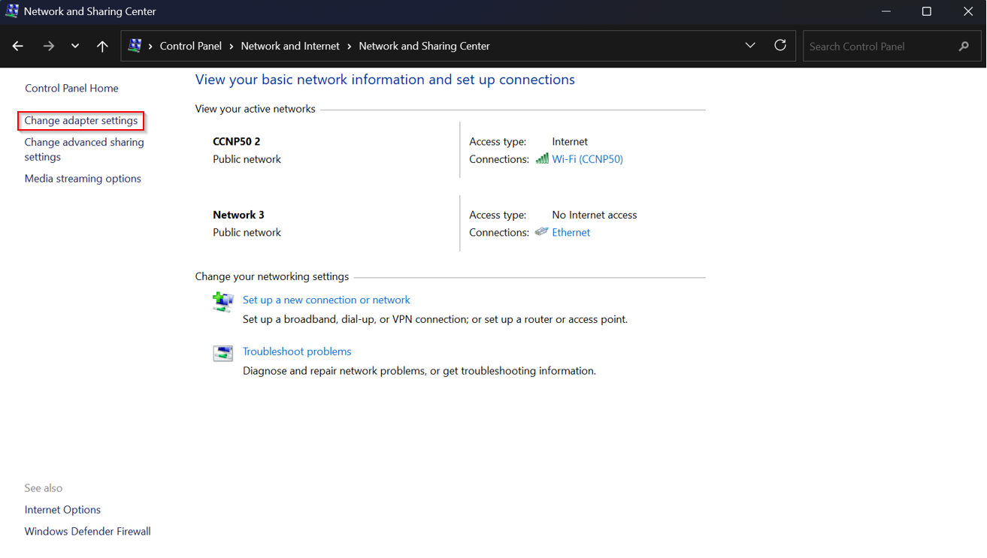

Locate the Ethernet connection and double click it. Then, find Internet Protocol Version 4 (TCP/IPv4) and double click on it.

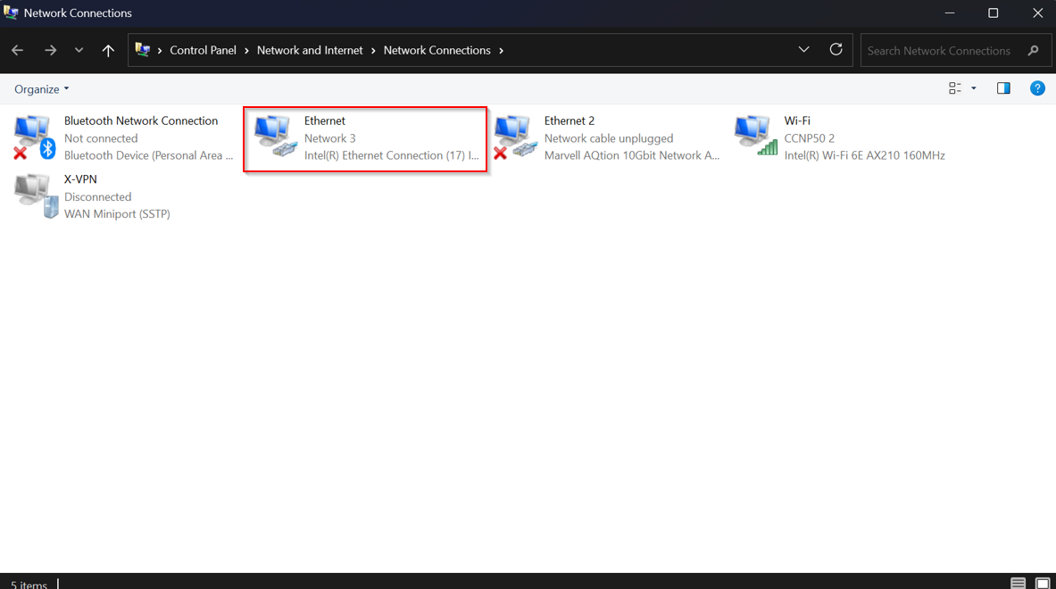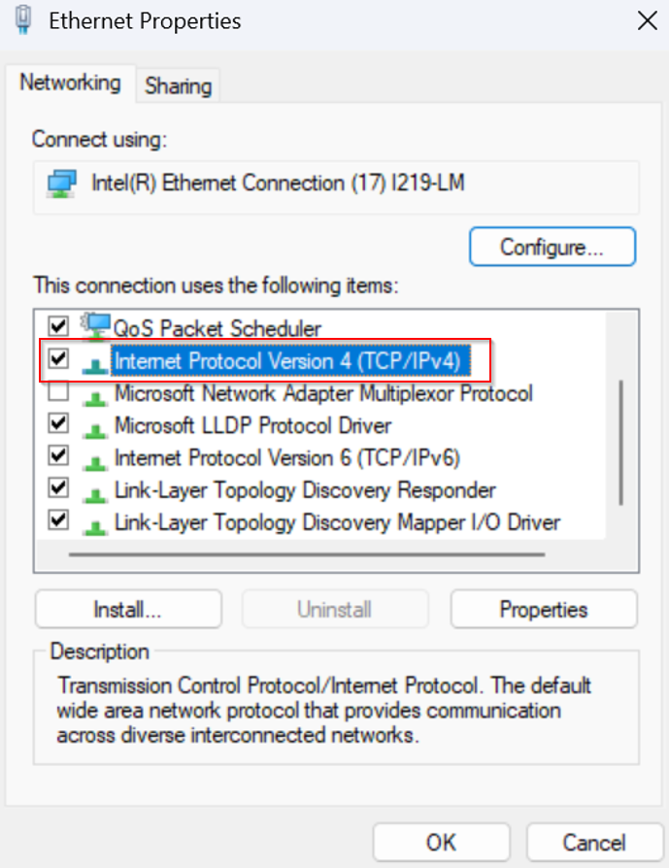

Select Use the following IP address and enter the assigned IP address and subnet mask. Make sure to click OK to save your IP address configuration.
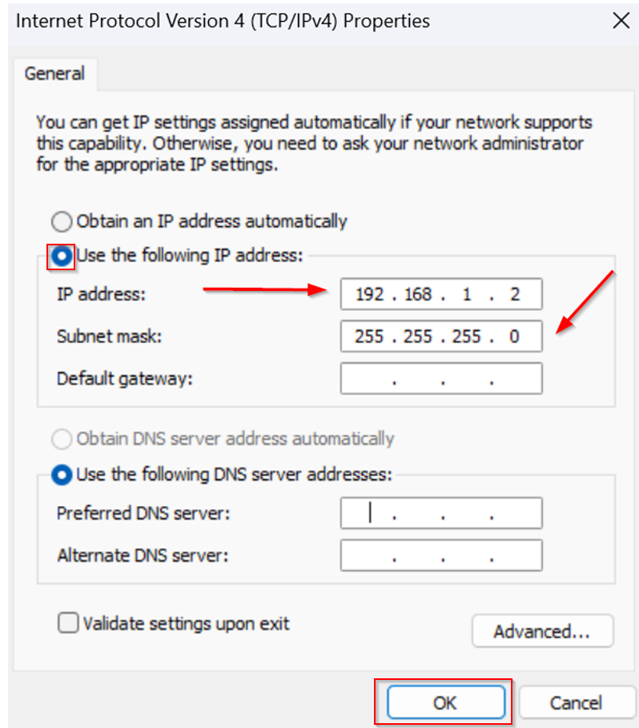

Head over to your firewall WebGUI and enter in your information.

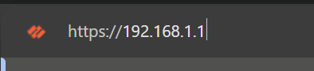
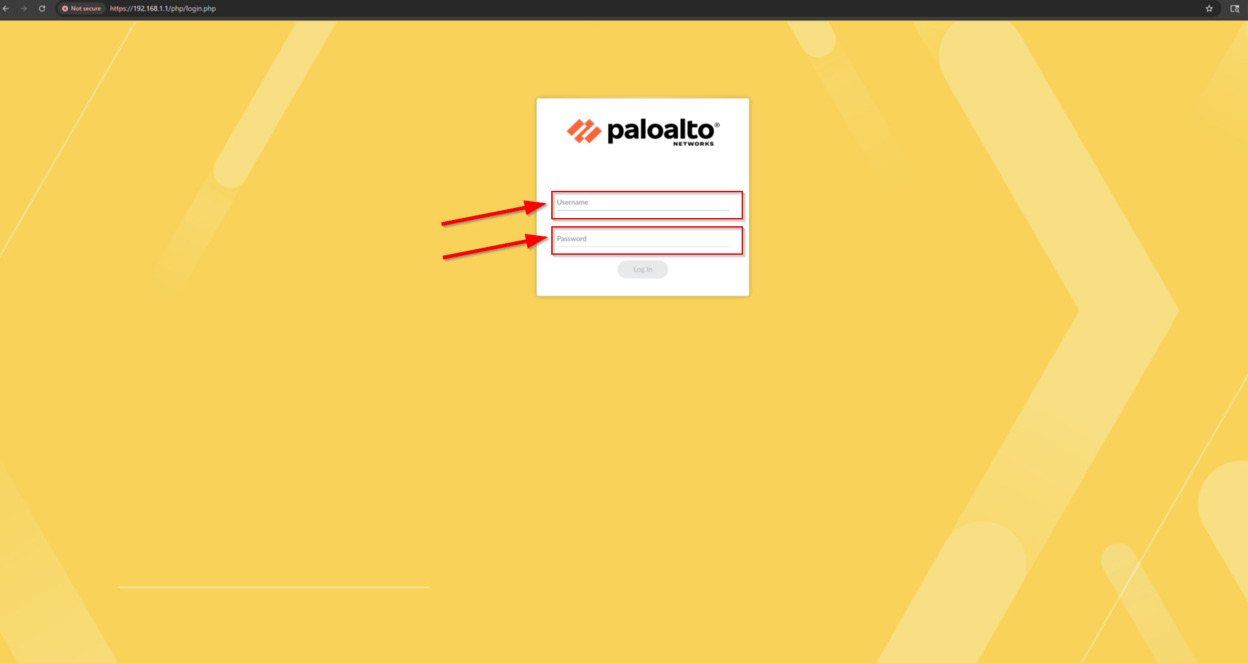

In your PA-220 firewall interface, go to Network Zones.

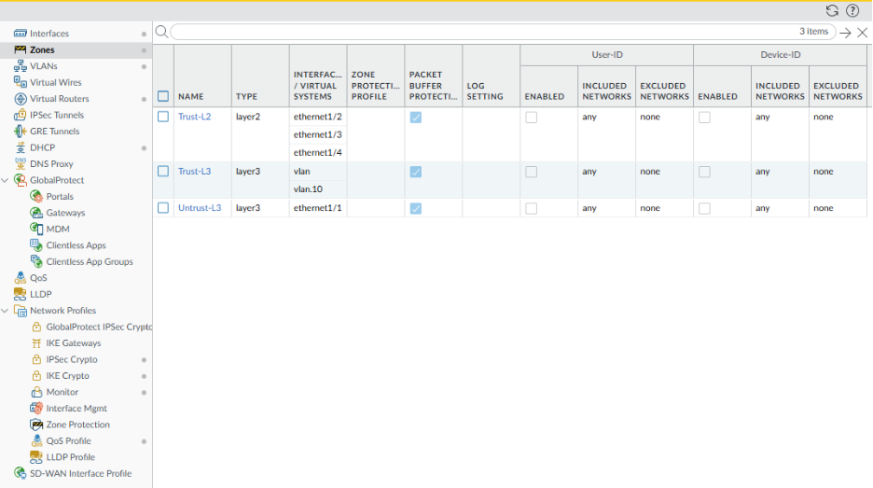

In the bottom left corner, locate the Add button. Create Zones Untrust-L3, Trust-L3, and Trust-L2 with the exact same configuration as in the pictures below.

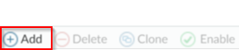

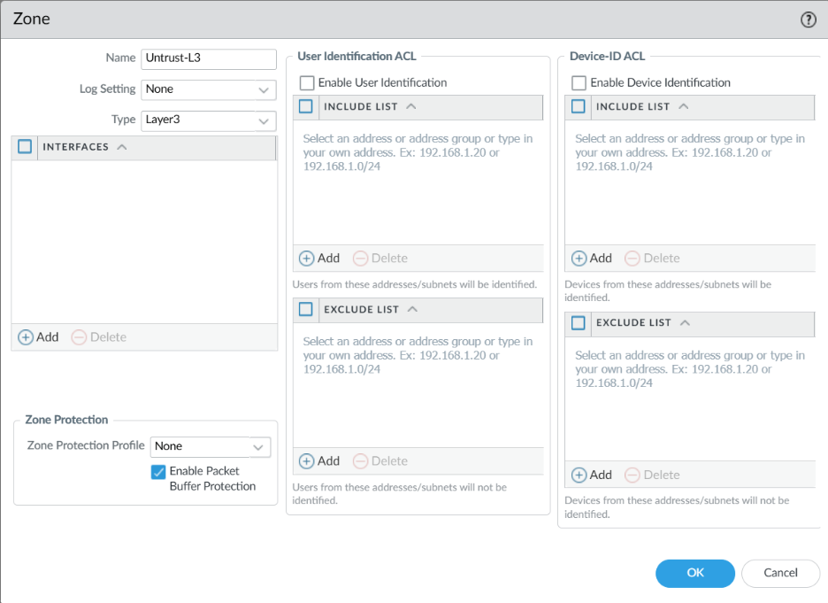

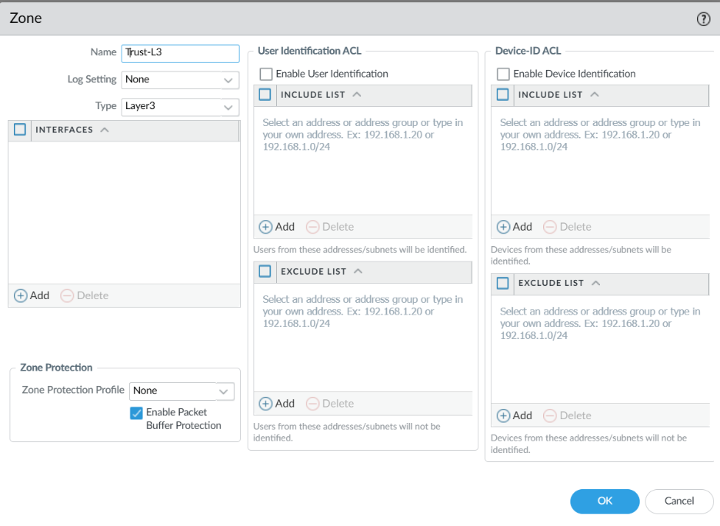
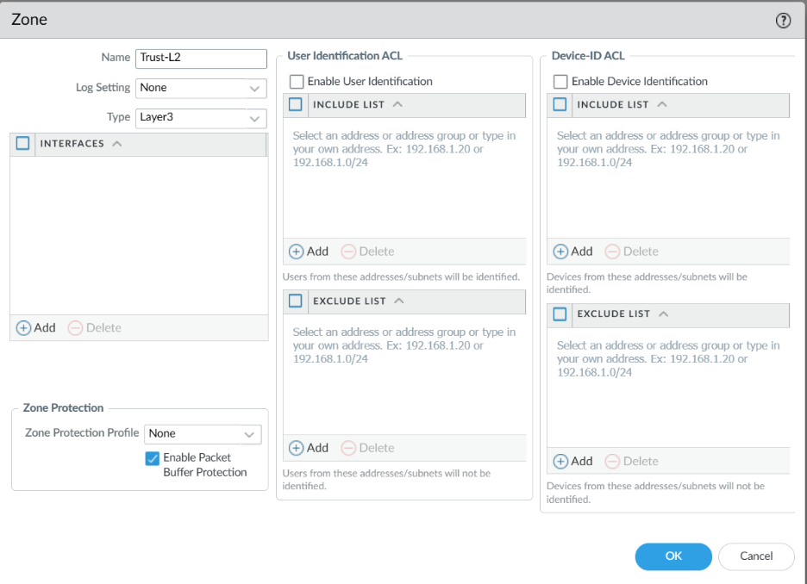

Then, go to Network Interfaces and configure ethernet 1/1. Then, copy the configuration.

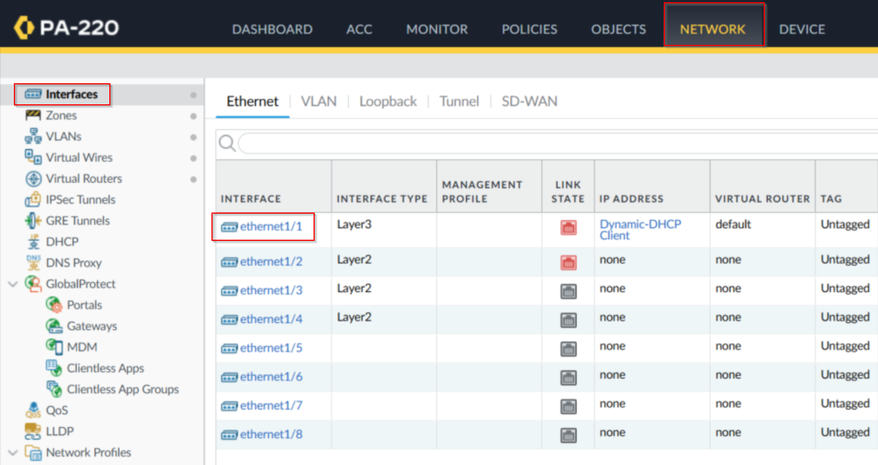
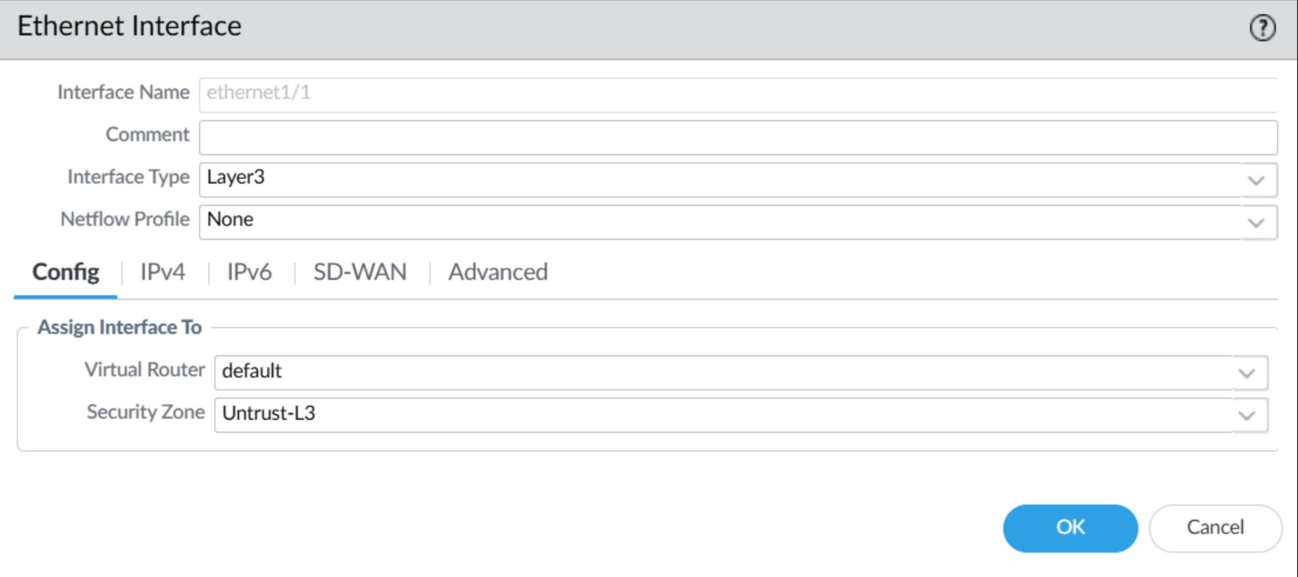
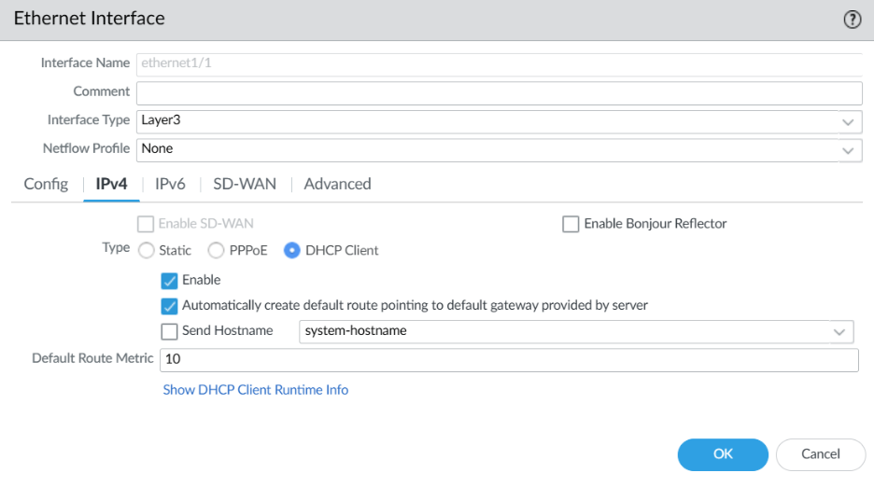
Then, create a VLAN Object. Go to Network Vlans and click Add.

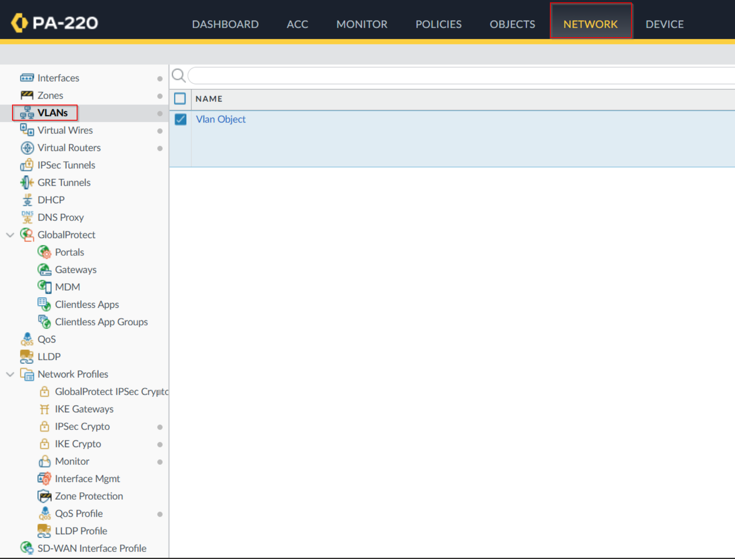

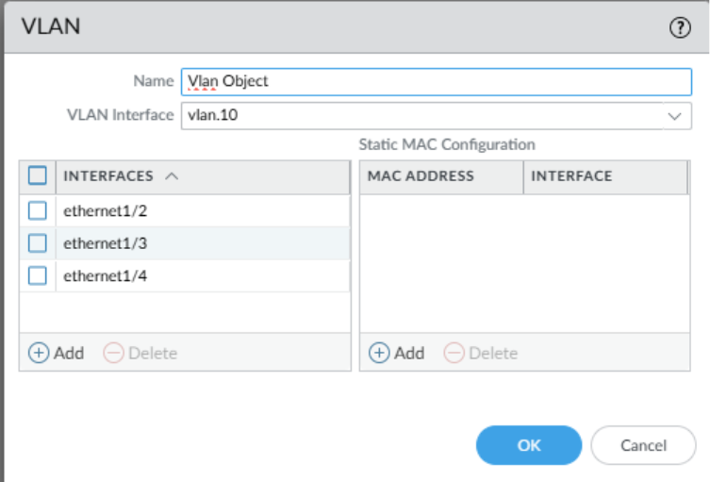

To configure Layer 2 ports and VLAN Object, go to Network Interfaces Ethernet. Configure the following configurations for ethernet 1/2, ethernet 1/3, ethernet1/4 interfaces.

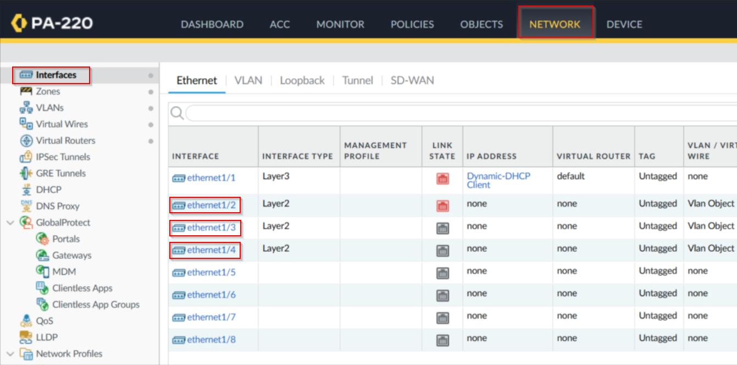
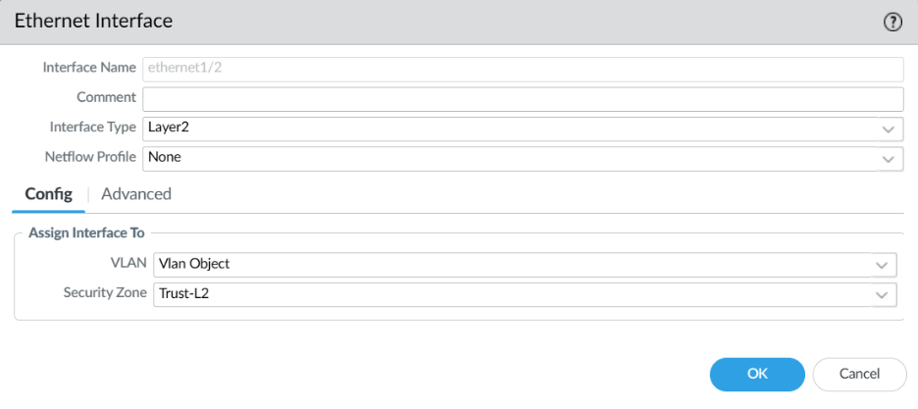
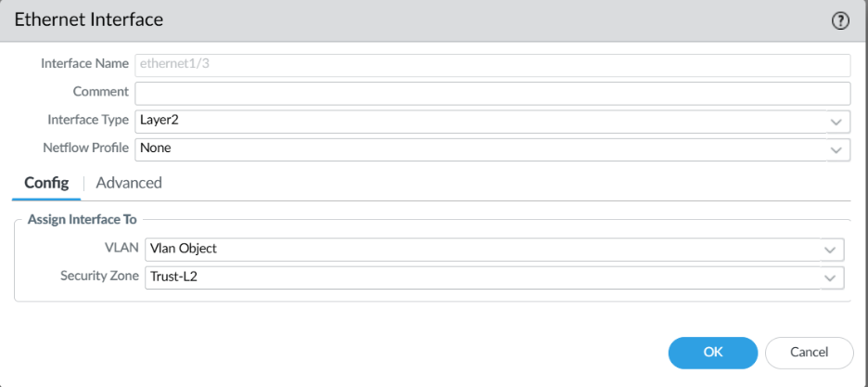
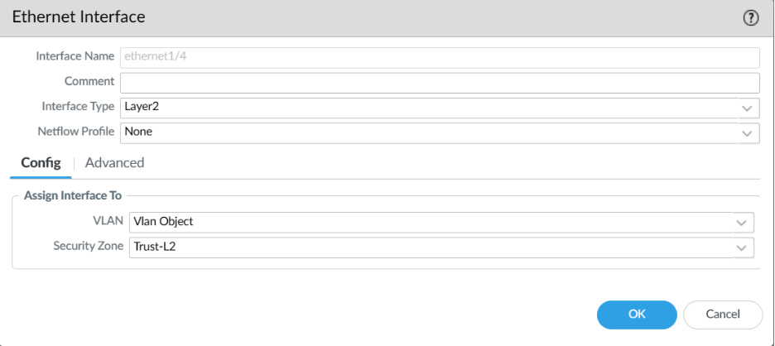

To configure the VLAN interface, go to Network Interfaces VLAN and edit the following configuration:

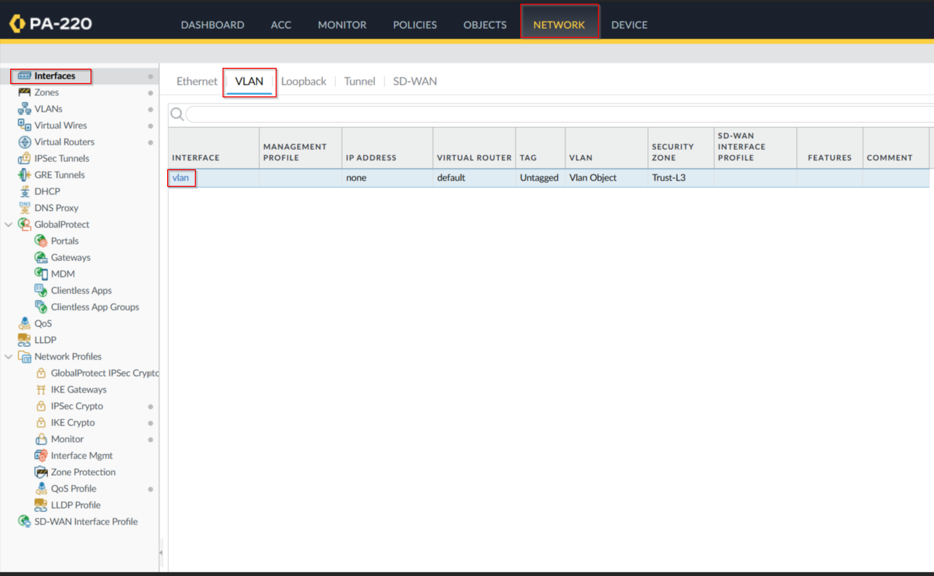
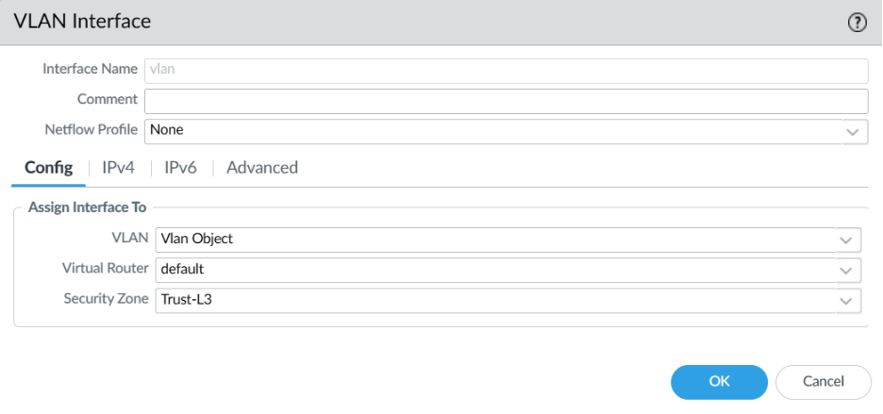
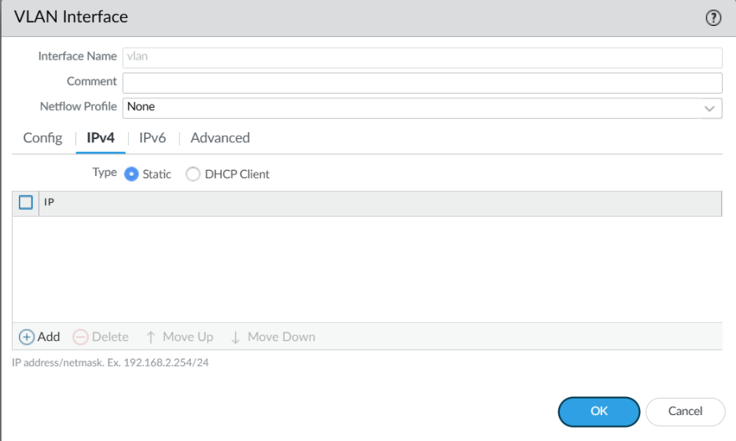

Press Add and configure IP to 192.168.1.254/24

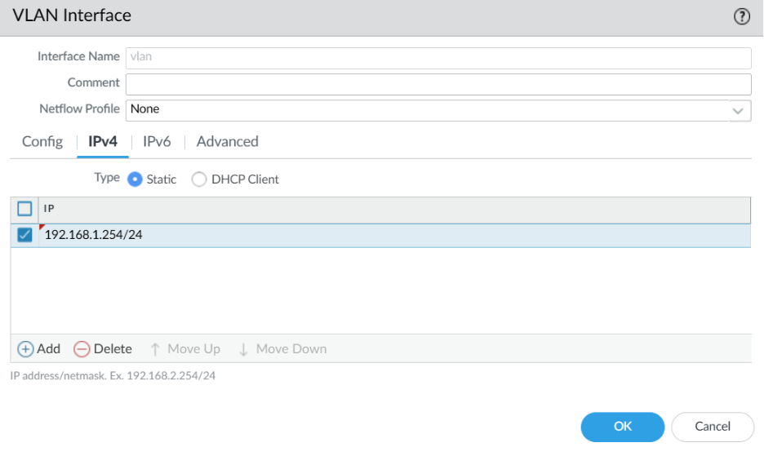
To configure the DHCP server, go to Network DHCP DHCP Server and click Add. Edit the following DHCP Server Configurations.

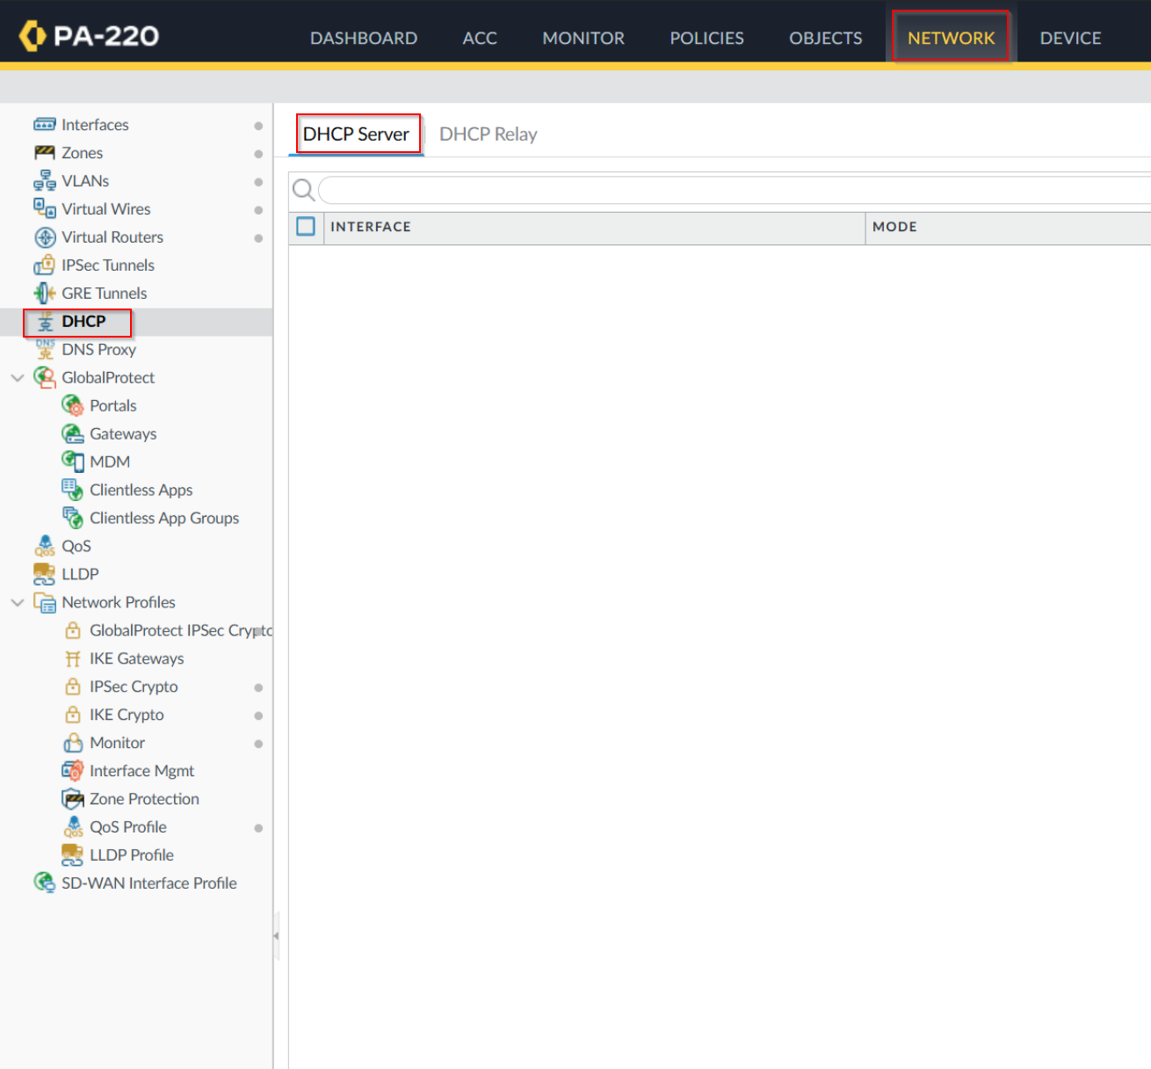
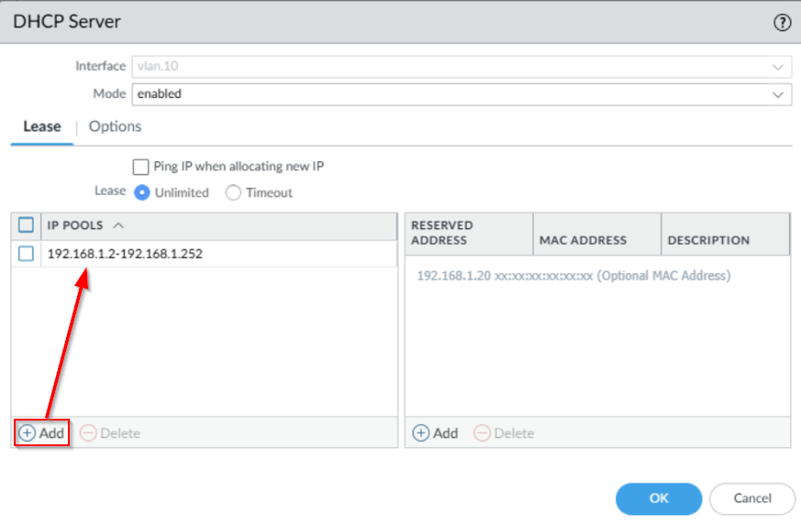
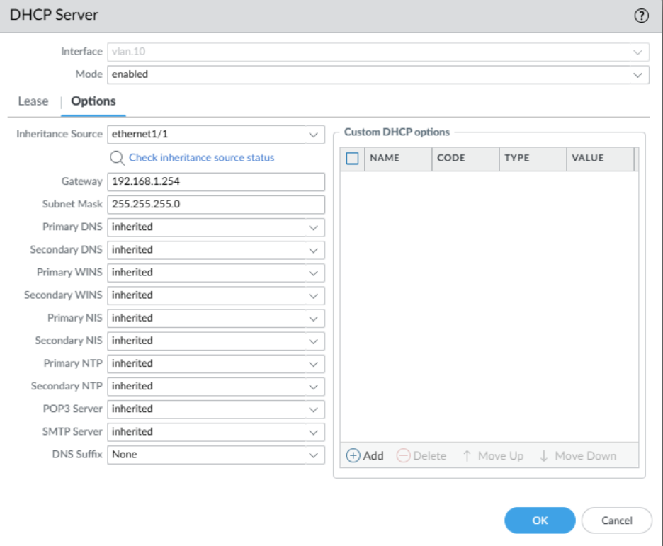

To define a Security Profile Group, go to Objects Security Profile Groups and click Add. Configure the Security Profile Group as recommended.

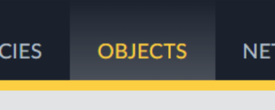
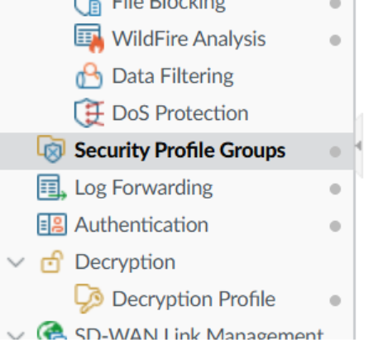
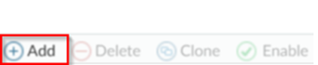
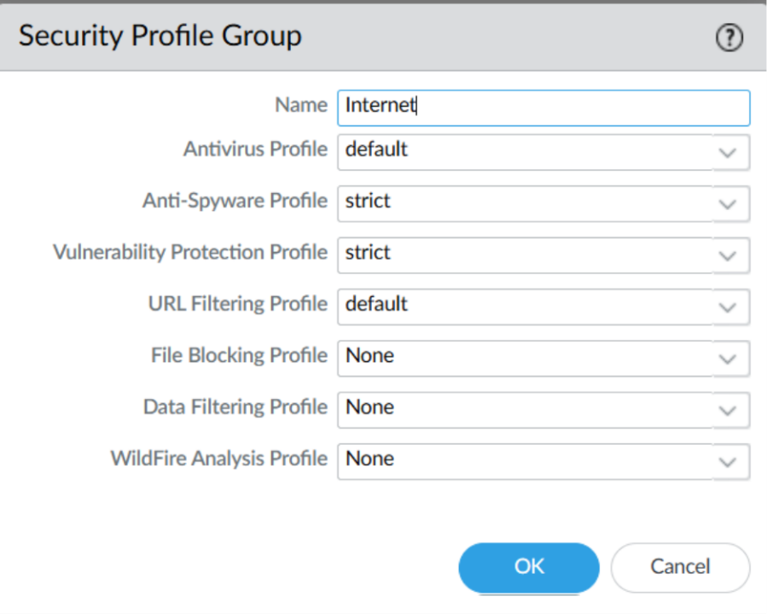

To Create an Outbound Internet Security Policy, head over to Policies Security and then click on Add. Enter the following configurations.

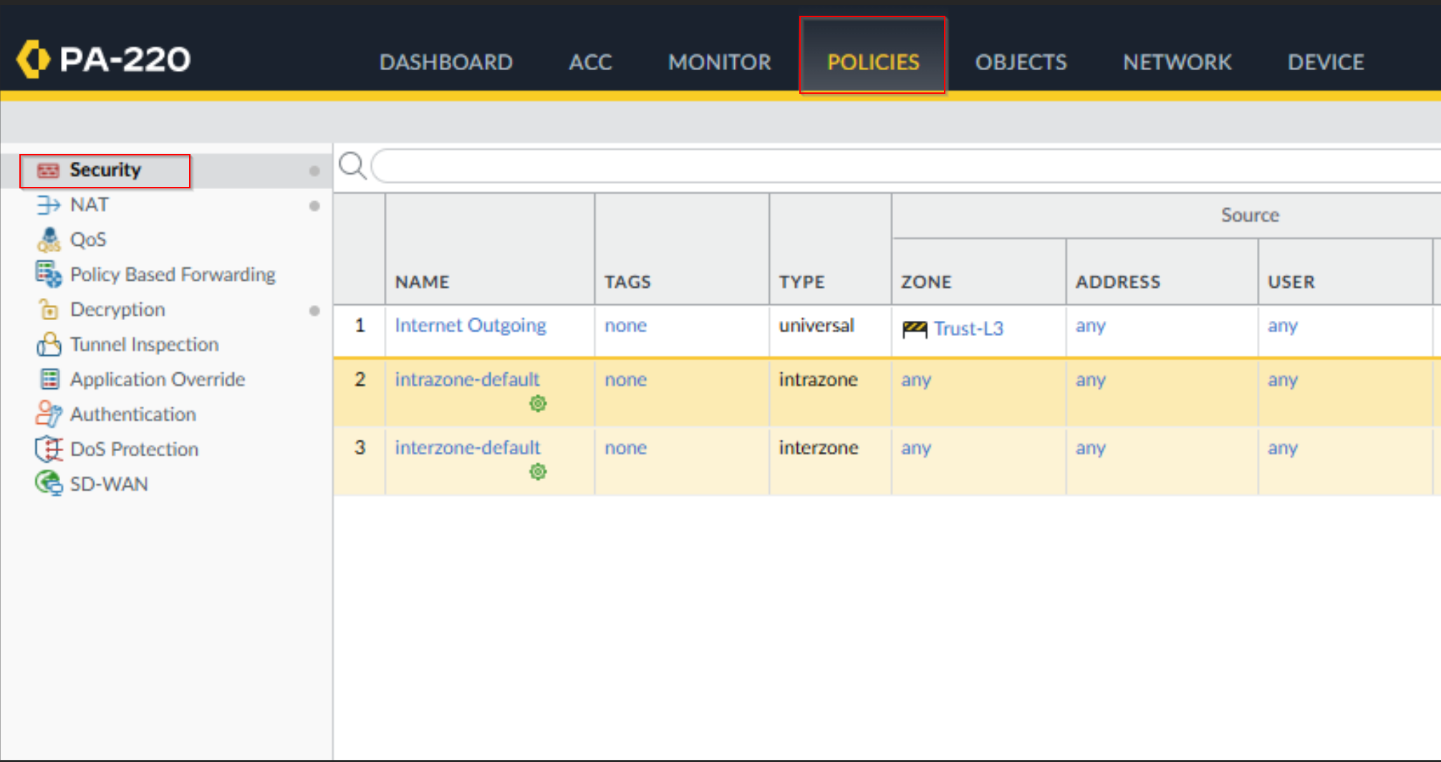

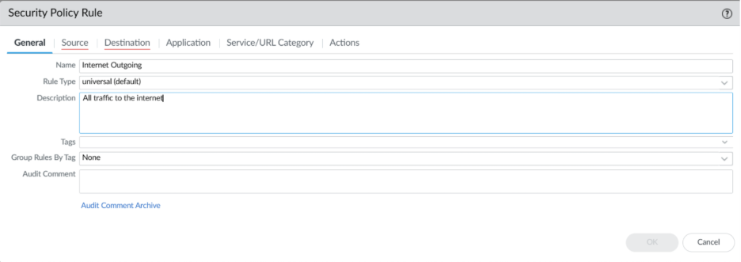
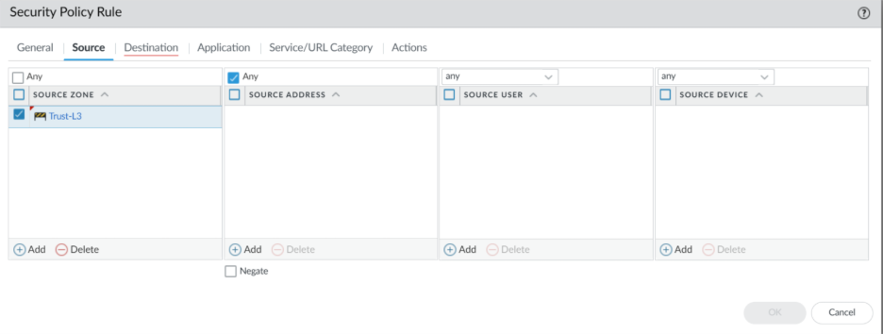
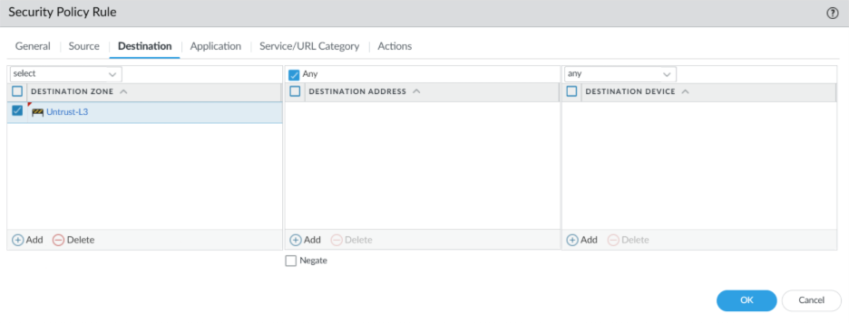
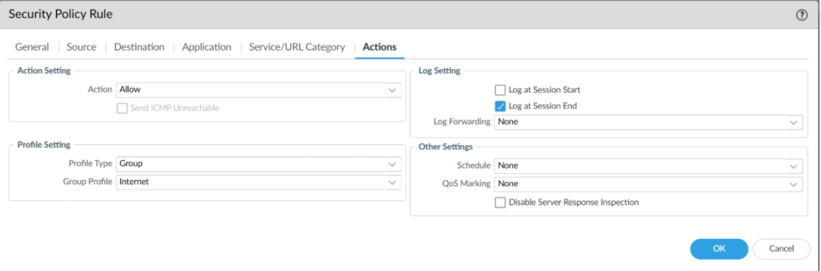

To configure Outbound Internet NAT Policy, go to Policies NAT Add. Give the policy a name and copy the configurations.

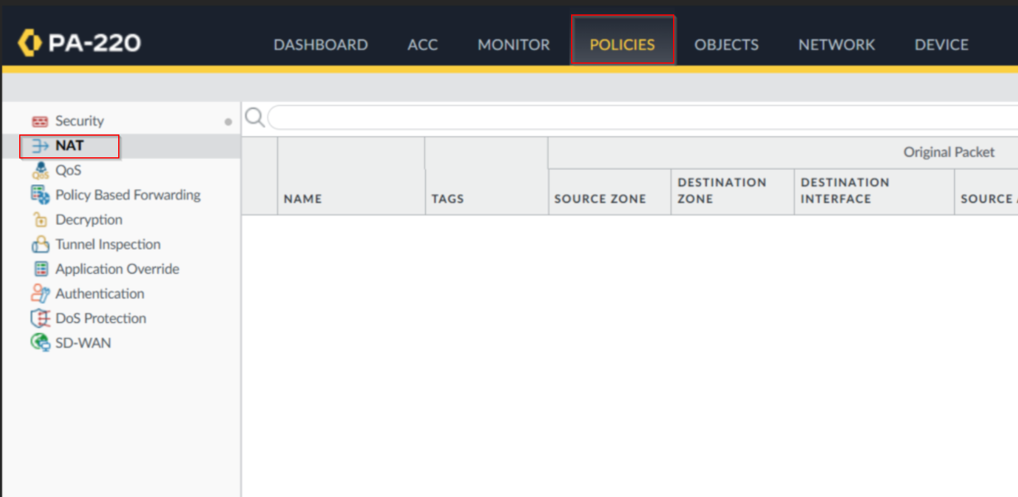


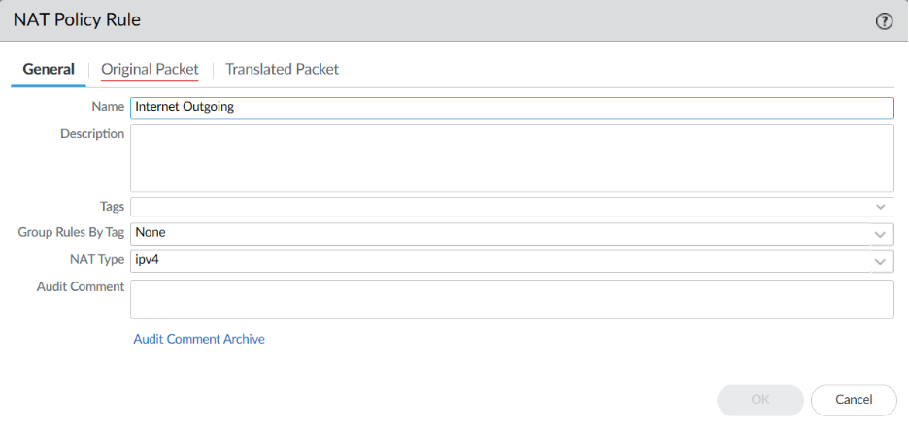
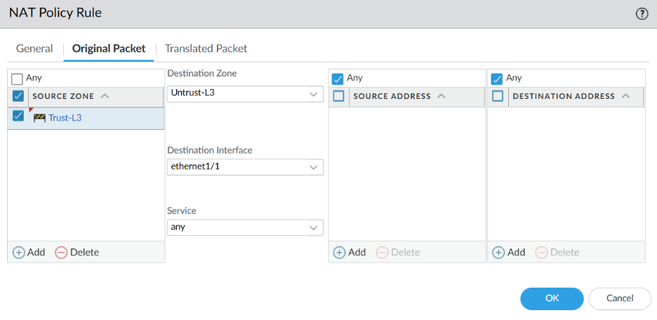
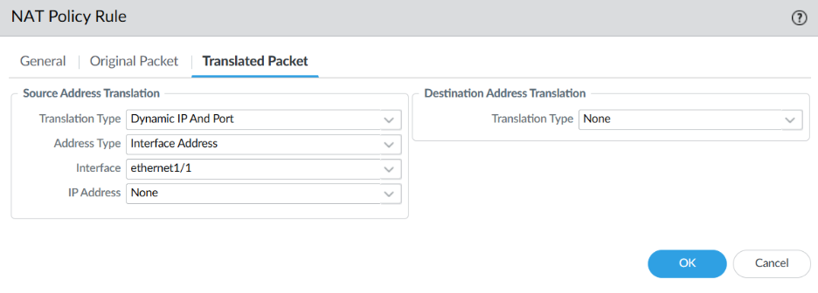

To configure the MGMT IP, go to Device Setup Interfaces and click on Management. Copy the configurations for Management.

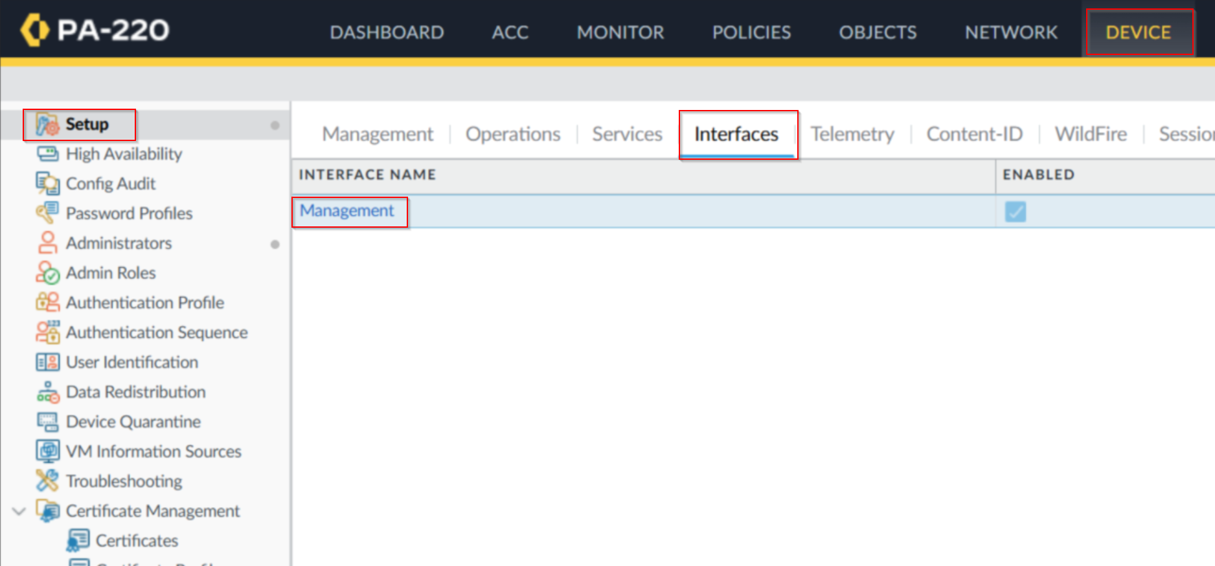
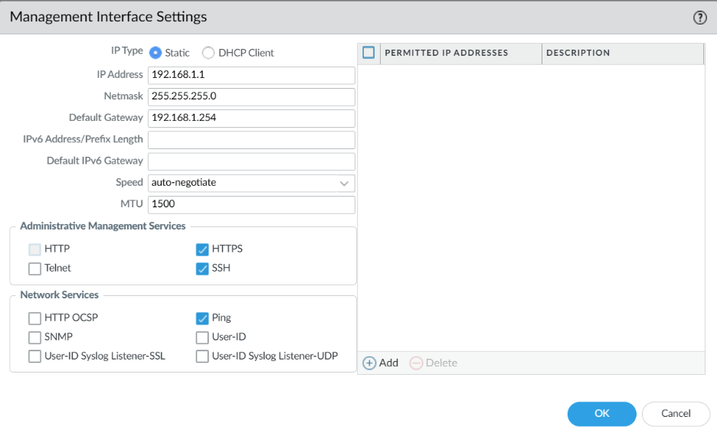

To set up DNS for MGMT, head over to Device Setup Services. Click on Service Route Configuration and copy these configurations.

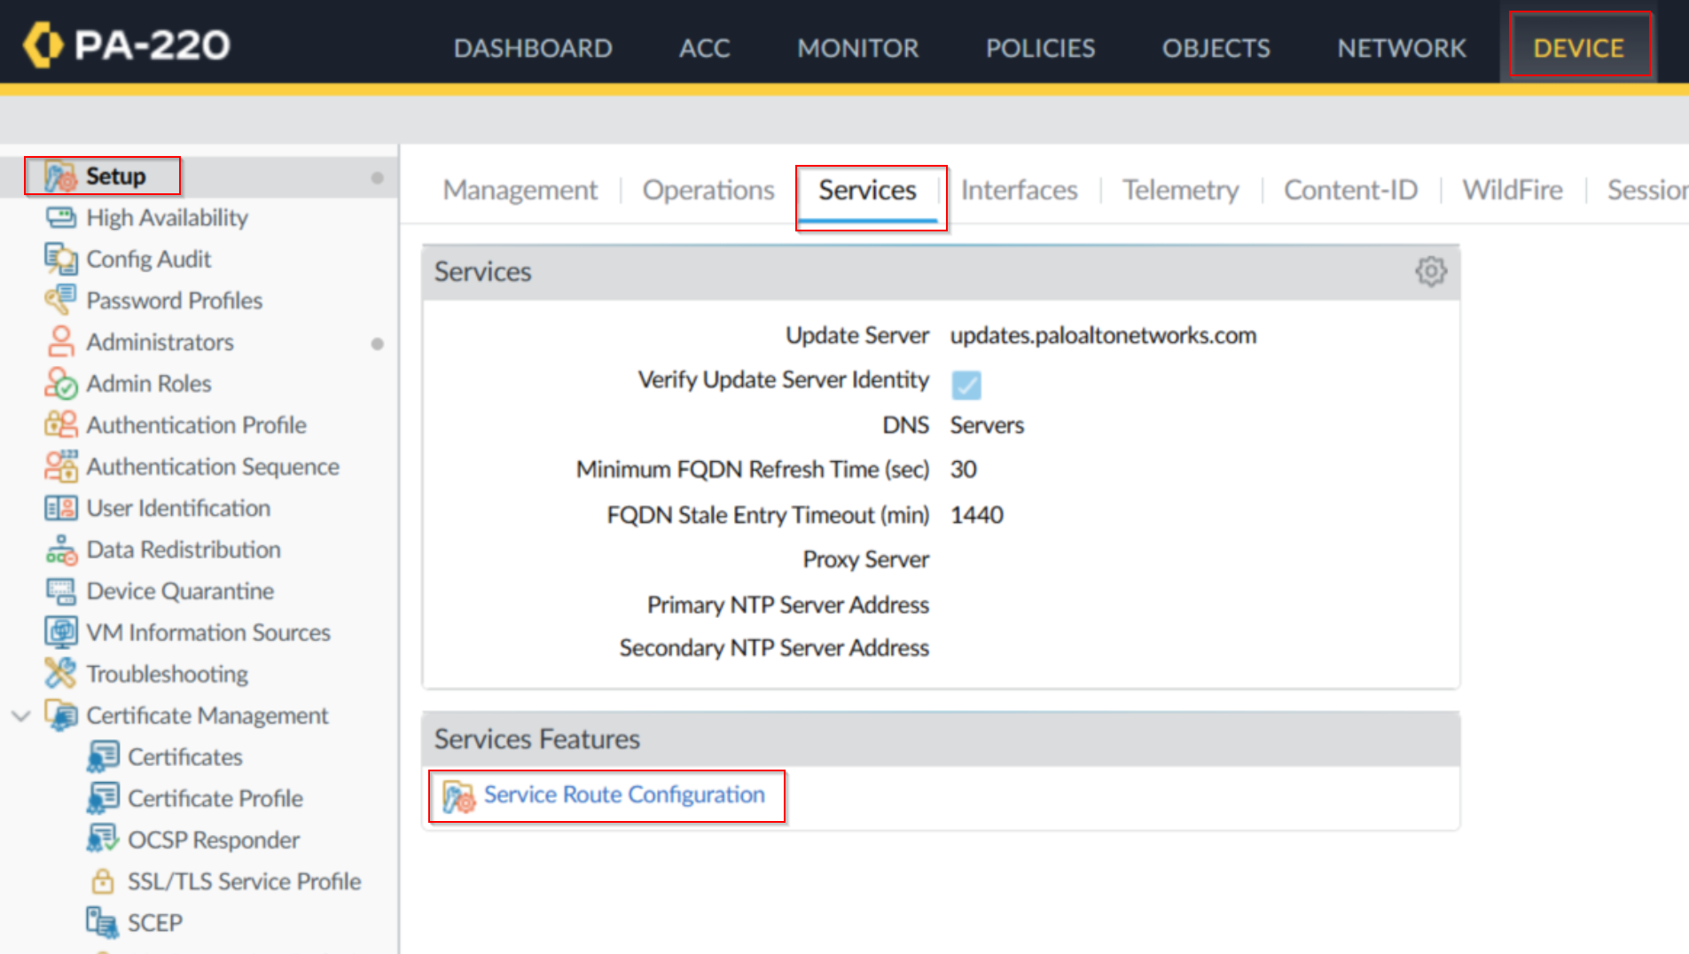
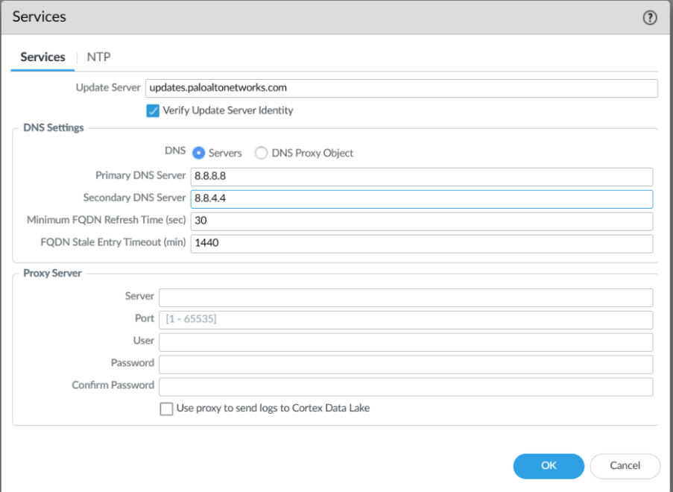

After this, your SOHO environment setup should be complete. Last thing to do is to make all your changes. In the top right corner, look for commit and review your commit history. When finished, press Commit.

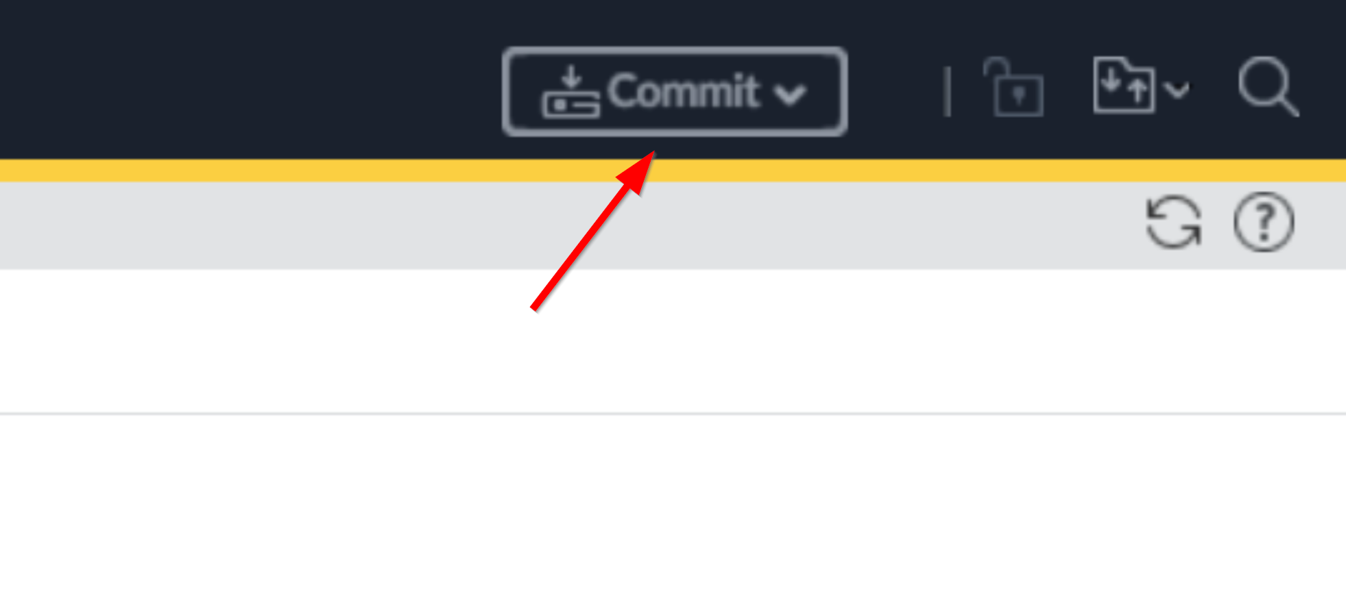
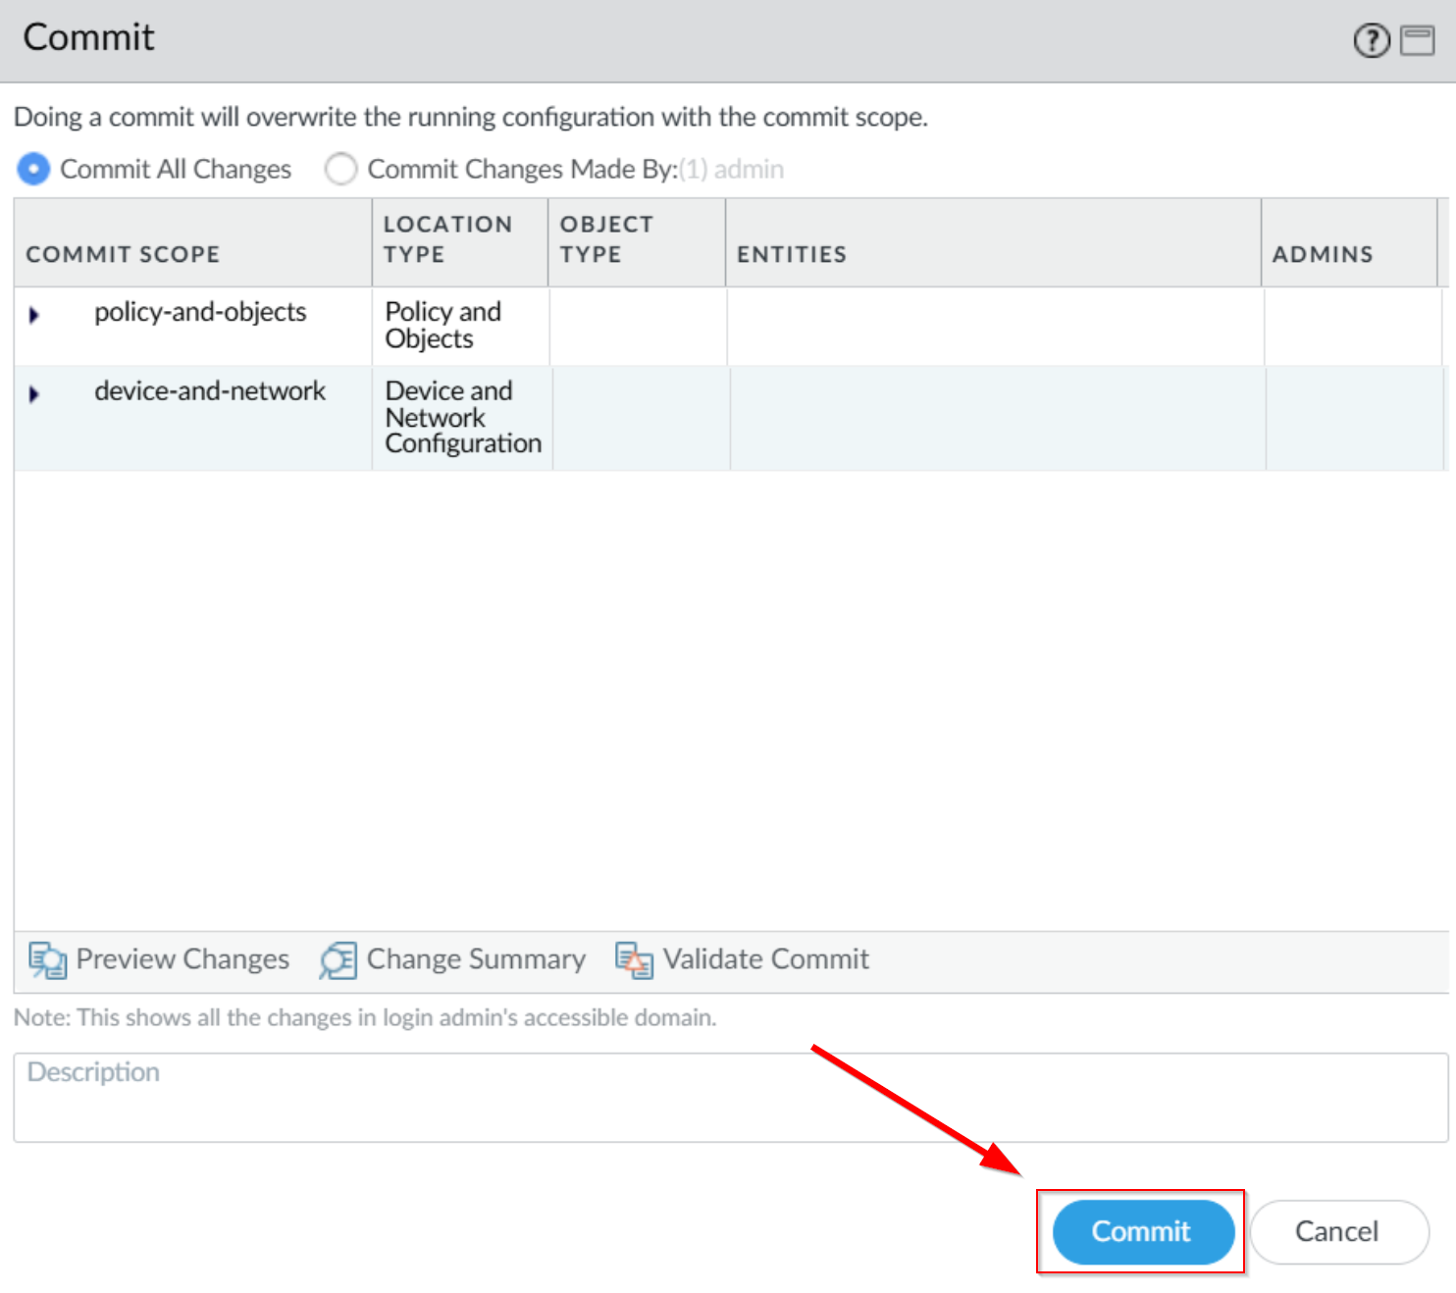
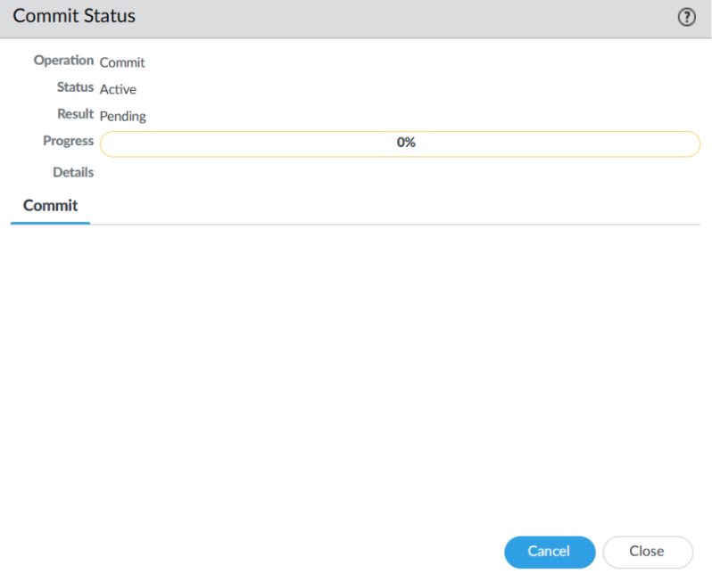
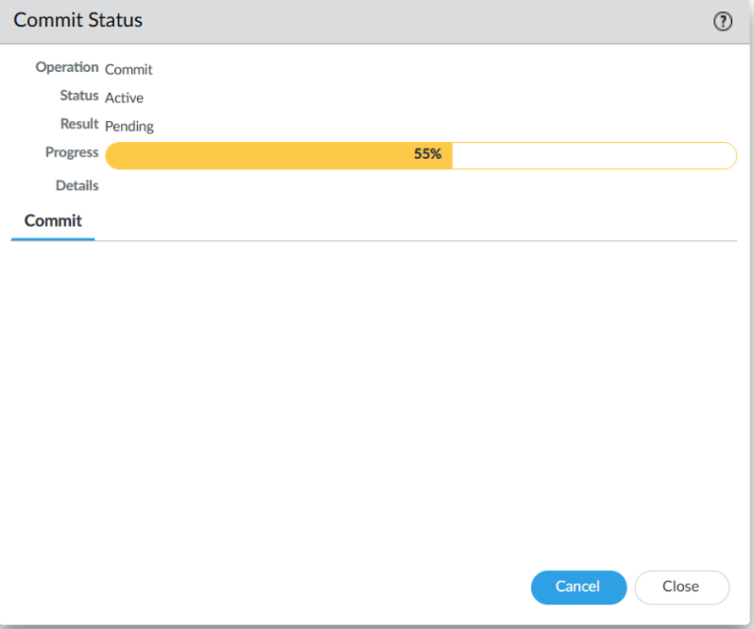
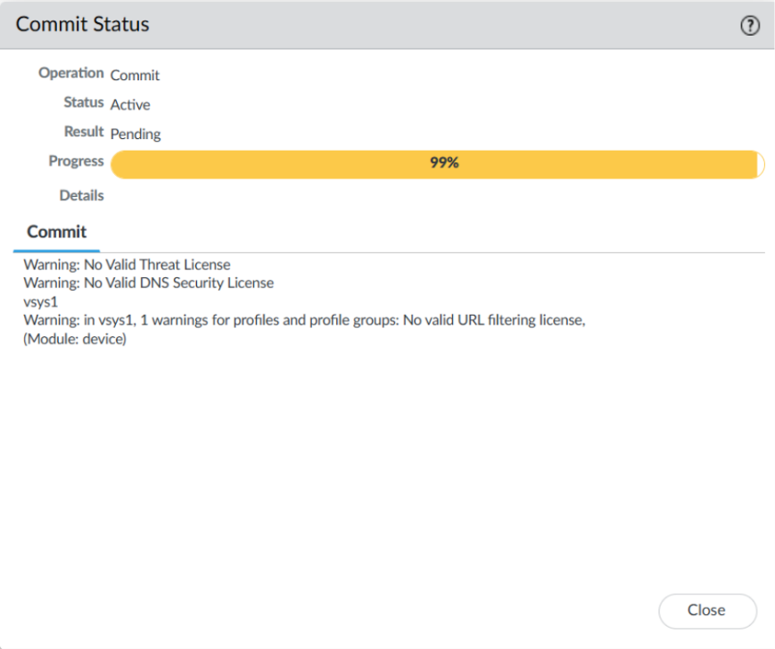
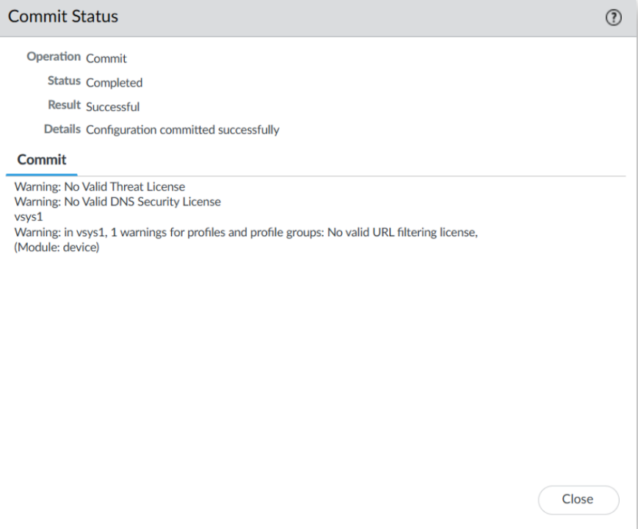

If your Commit Status states that the operation of the commit was successful, congrats. You have completed your SOHO configuration! To test the functionality, refer to the Configuration Tab up above for AFTER committing. Adjust your topology to that topology, disconnect from your main internet, and test if you can access the internet through your firewall.

Problems:

No problems were encountered.

Conclusion:

In conclusion, this lab has introduced hands-on experience of managing a Palo Alto PA-220 firewall within the context of SOHO configuration. Furthermore, I’ve learned the histories and application of what a SOHO environment could provide and was surprised to see that PA-220 firewalls can function as an enterprise-class firewall despite its miniature size. This lab has strengthened my fundamentals with WebGUIs along with the importance of deploying firewalls within a SOHO configuration.

Teacher Signoff Page of Lab Completed:

